- https://localhost:44301/User/Noting_Page?fileCode=soft%2Fbackdev%2FADV%2F8%2F001%2F2026 in this page , after submit the final noting button is still are enabled to do another noting .
- When submit noting as final noting and then forward file to the higher authority
Show error ..
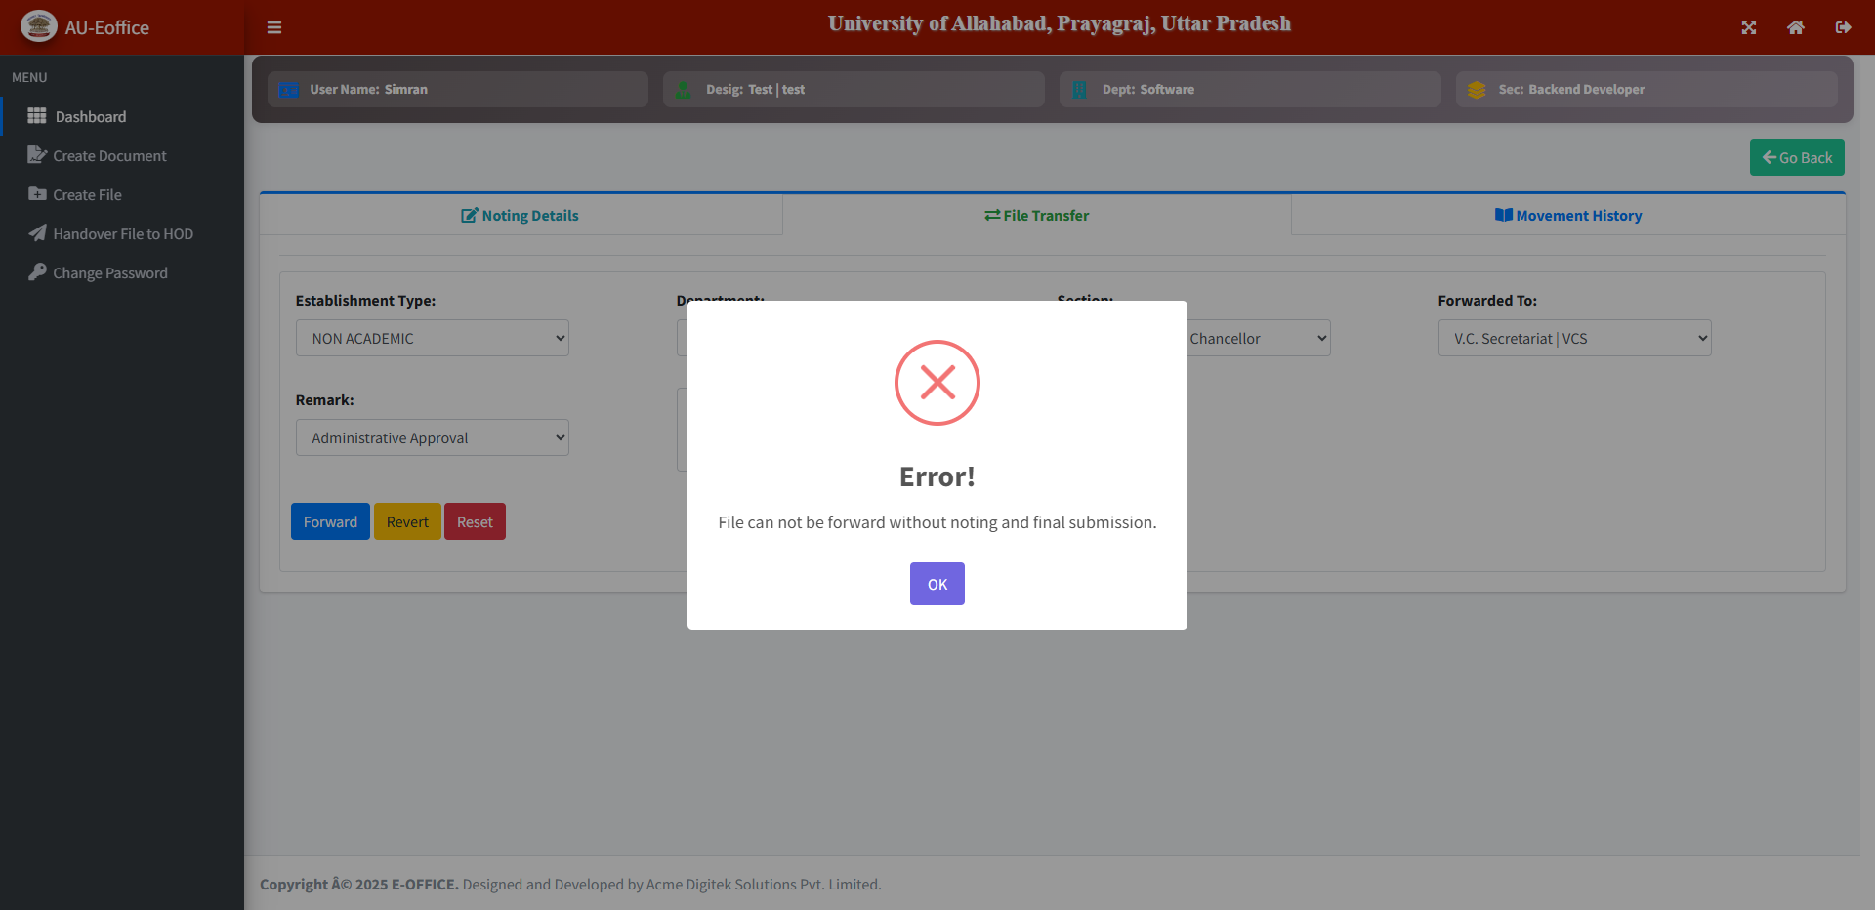

- Noting in green section is not show in order, note 2 is show before note 1 as shown in screen shot. 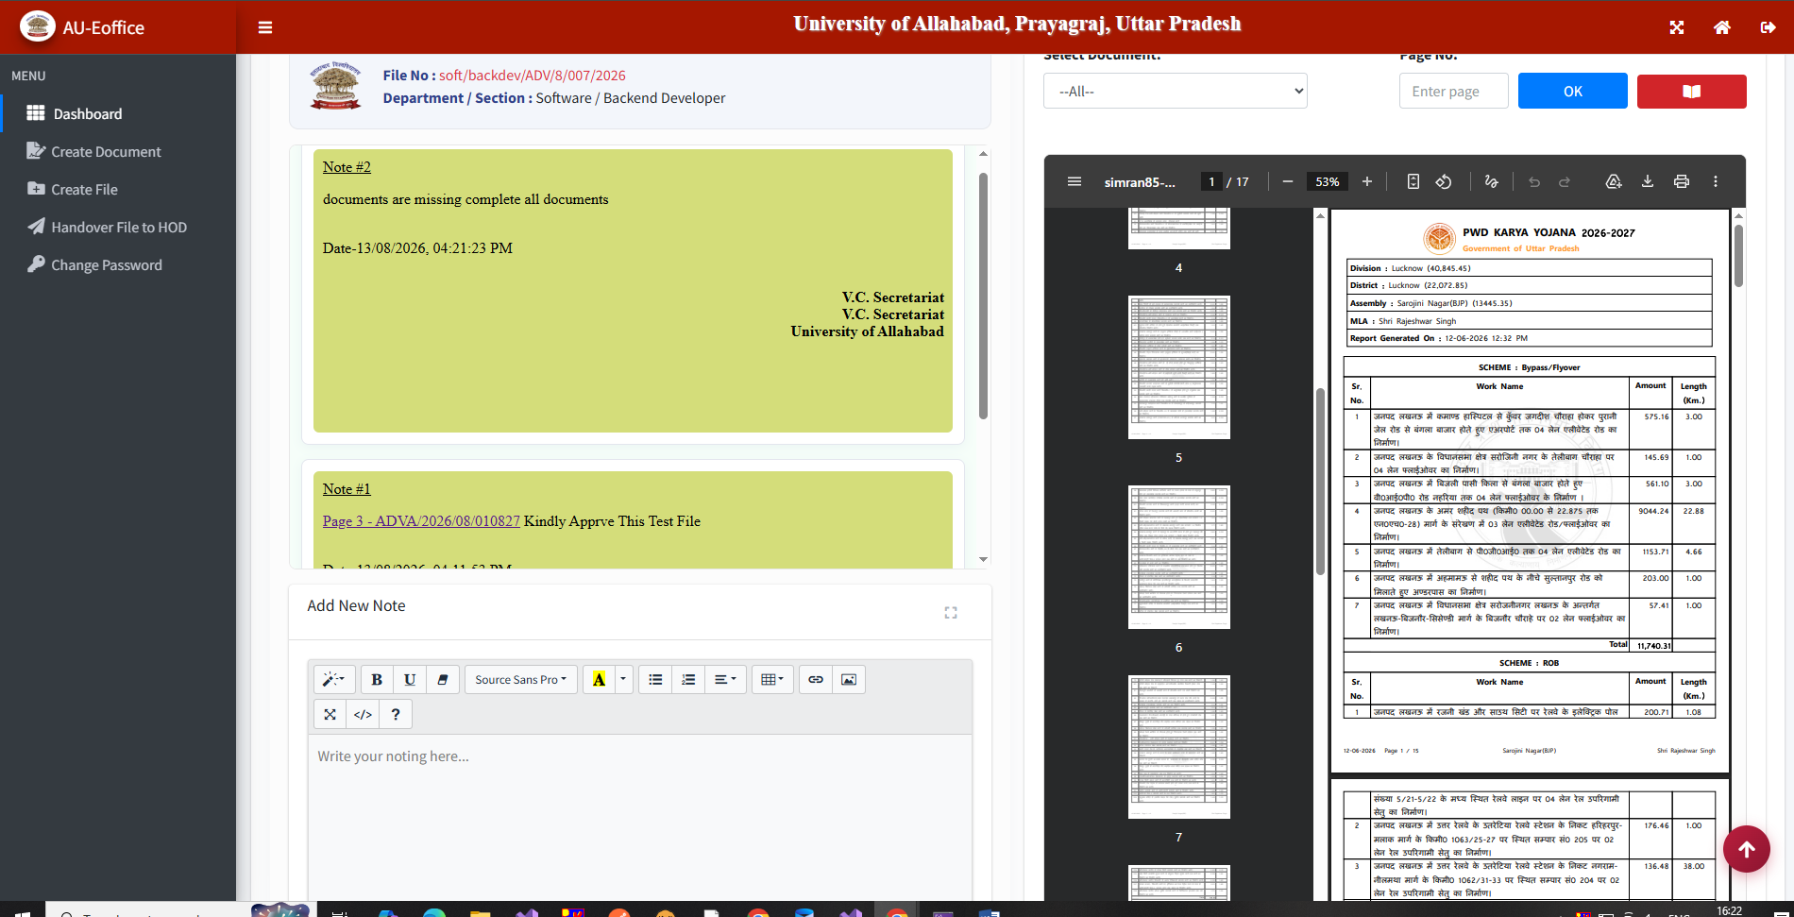
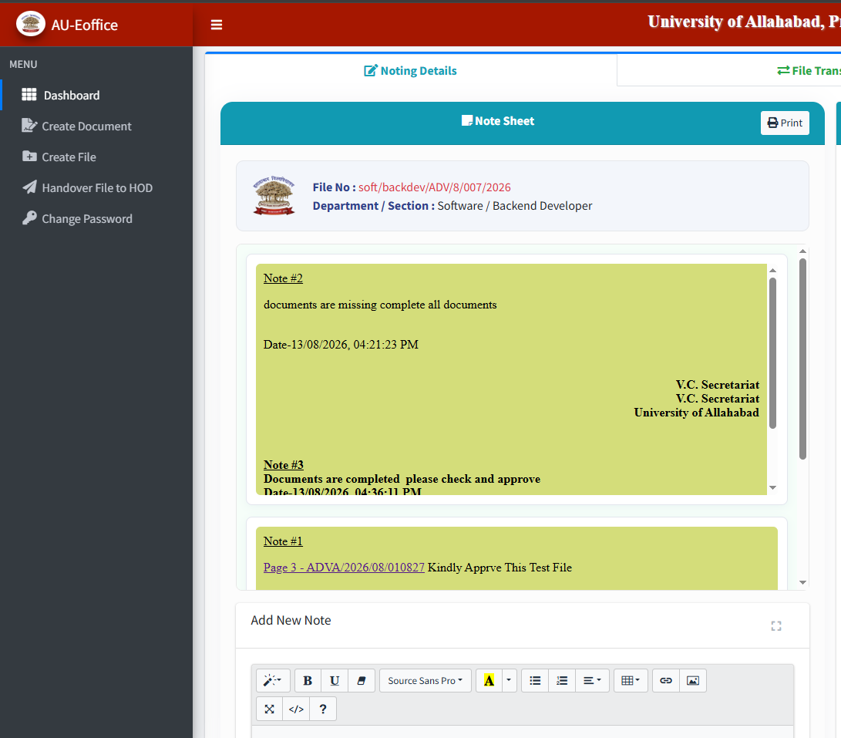

- When Vijay send any file to vc sec then vc sec forward file as internal movement to registrar then it is not forwarded.
Vjiay vc sec registrar (As internal movement)
After vc sec successfully forward file as internal movement then on registrar end this file will show in inbox tab on dashboard.
- https://localhost:44301/User/Files_History on dashboard in file_history tab documents are attached but still not show when we click on attach document column icon this message is show in alert( No attached document exists for this file.)
- https://localhost:44301/User/Files_History Search by file no and search by date filer is not working as shown in given picture below
|
\|/
\/
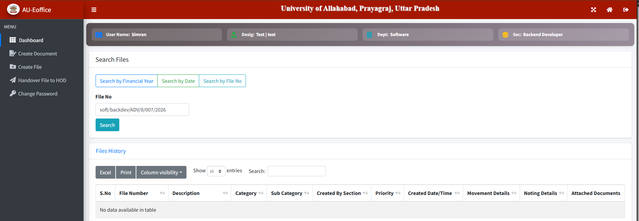

- Handover File is not working jise handover krna hai unke name nhi aa rahe hai dropdown mei

